**ADAMSON UNIVERSITY**

**COLLEGE OF ENGINEERING**

**COMPUTER ENGINEERING DEPARTMENT**

**DATABASE DESGIN AND DEVELOPMENT LAB**

58018 / 14:00-17:00 / 0Z212

**CONDOMINIUM DATABASE**

Project Documentation

**Group D:**

Cuello, Darwin Jolo

Hamid, Saeed

Laserna, Justine

Mangaliag, Sanjiv

**Submitted to:**

Engr. Rafaello M. Baluyot

December 10, 2018

# DIAGRAMS

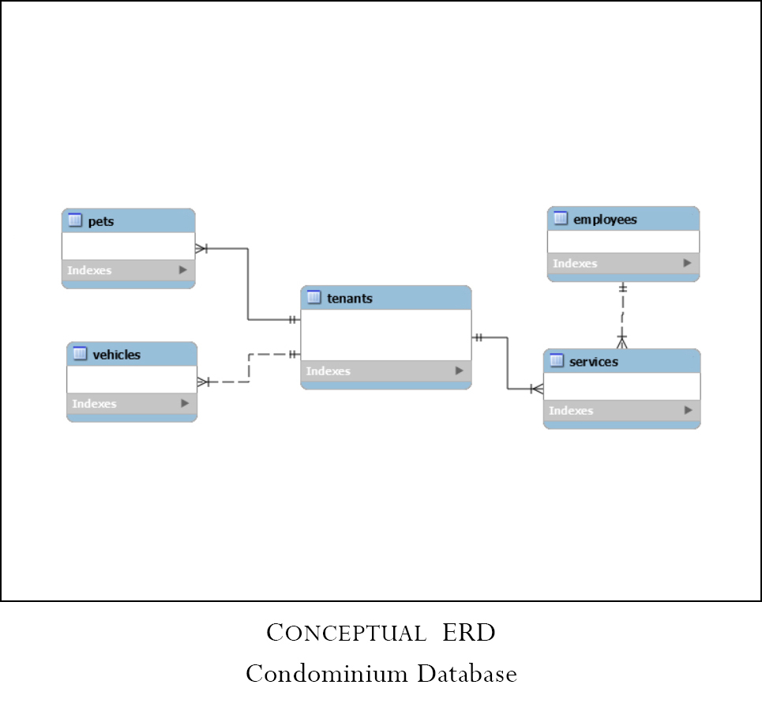

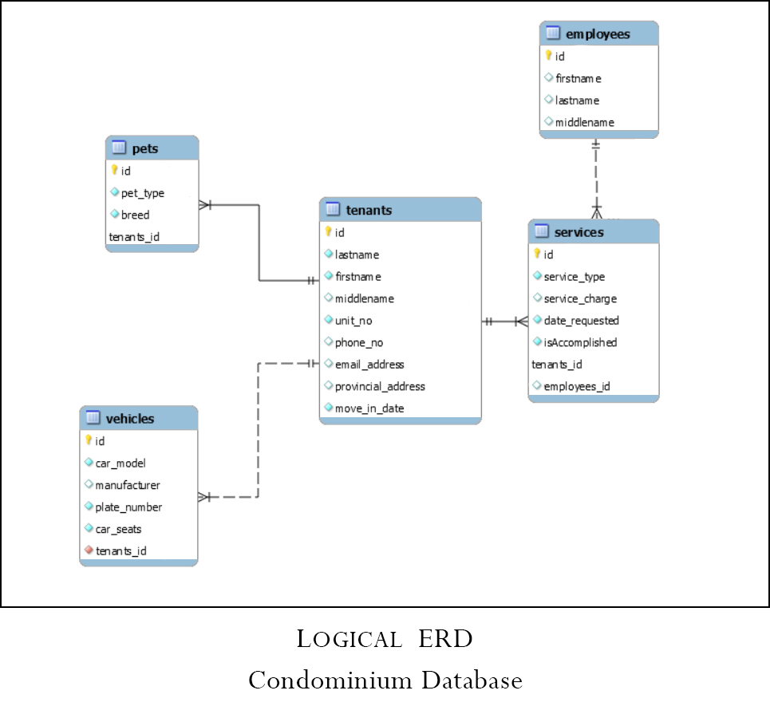

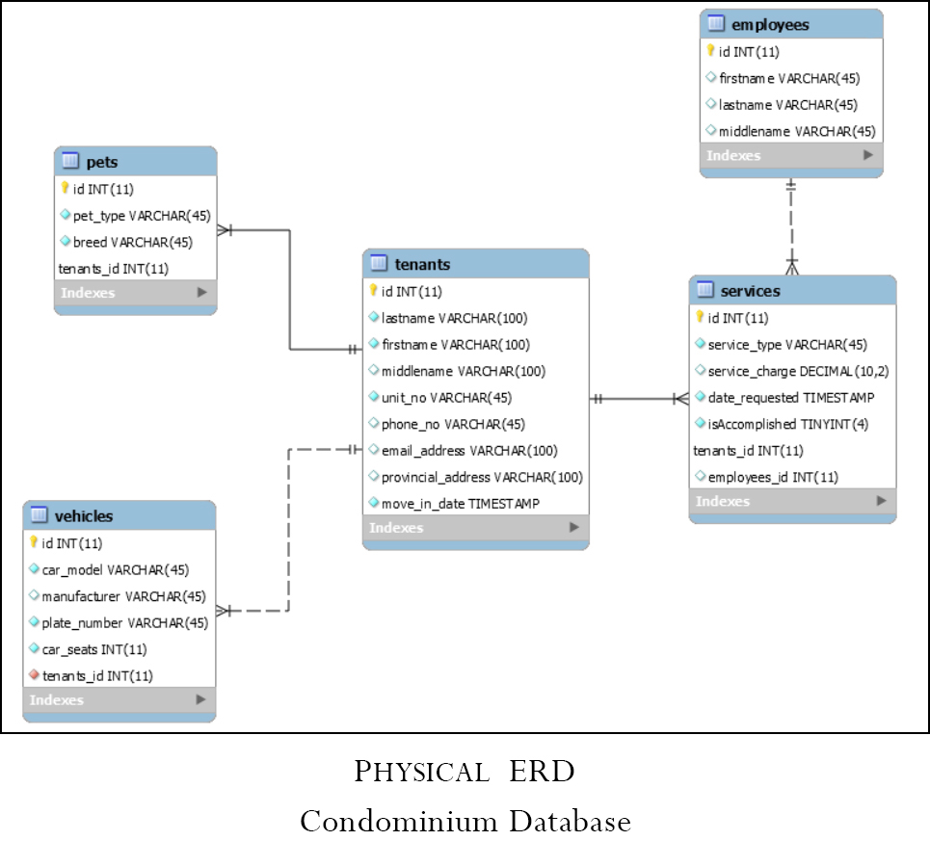

* STORED PROCEDURES

1. Get tenants with service request created before params

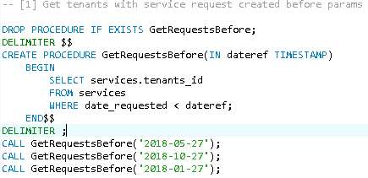

**GetRequestsBefore('2018-05-27');**

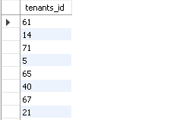

**>**sample output<

**GetRequestsBefore('2018-10-27');**

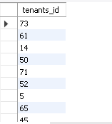

**>**sample output<

**GetRequestsBefore('2018-01-27');**

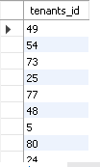

**>**sample output<

1. Get tenants and number of concerns (number of unsolved service request + approved vehicles + approved pet)

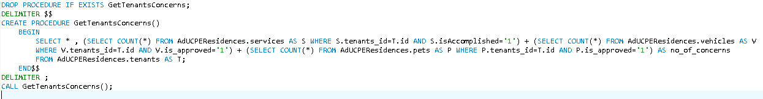

**GetTenantsConcerns()**

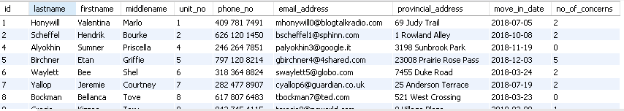

**>**sample output<

1. Get tenants with pets more than params

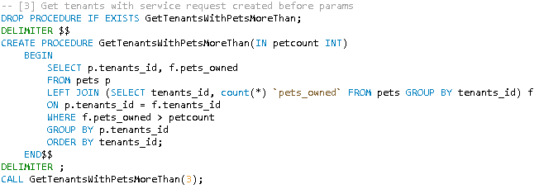

**GetTenantsWithPetsMoreThan(3);**

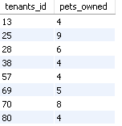

**>**sample output<

1. Get tenants with service request created before params

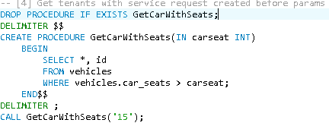

**GetCarWithSeats('15');**

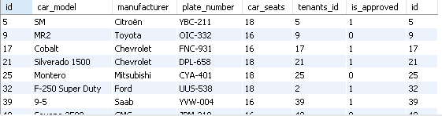

**>**sample output<

1. Get tenant whose number of solved requests is greater than the average solved request per tenant

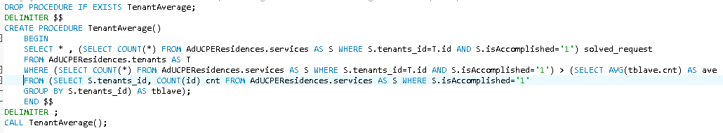

**TenantAverage()**

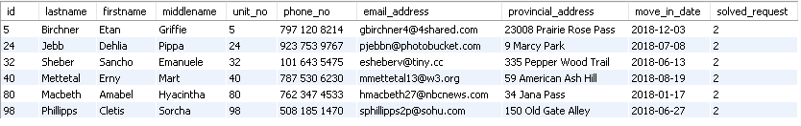

**>**sample output<

1. Total number of vehicles per tenant

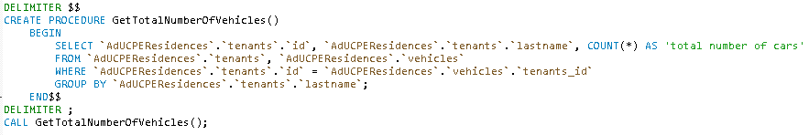

**GetTotalNumberOfVehicles()**

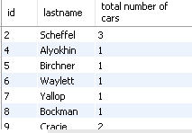

**>**sample output<

1. Total number of pets per tenant

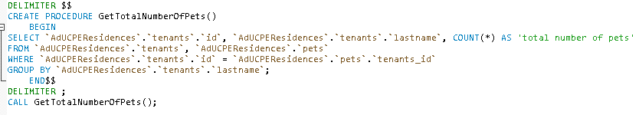

**GetTotalNumberOfPets()**

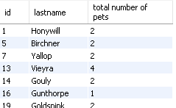

**>**sample output<

1. Total service charge per tenant

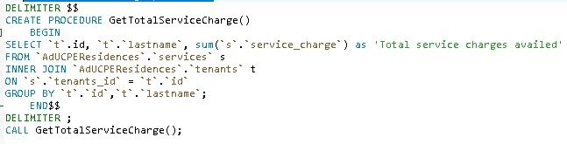

**GetTotalServiceCharge()**

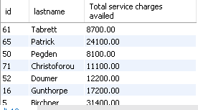

**>**sample output<

1. Total service fee per tenant

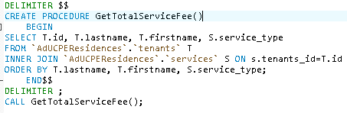

**GetTotalServiceFee();**

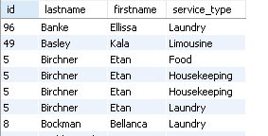

**>**sample output<

1. Total duration of stay per tenant

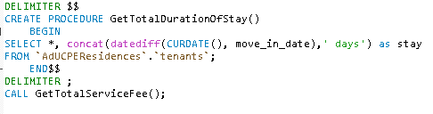

**GetTotalServiceFee();**

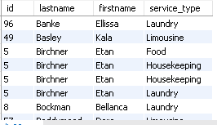

**>**sample output<

1. Add New Tenant

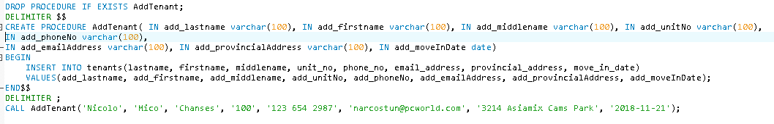

**AddTenant( IN add_lastname varchar(100), IN add_firstnamevarchar(100), IN add_middlename varchar(100), IN add_unitNo varchar(100),**

**IN add_phoneNo varchar(100),**

**IN add_emailAddress varchar(100), IN add_provincialAddress varchar(100), IN add_moveInDate date)**







**>**sample output<

1. Add New Vehicle

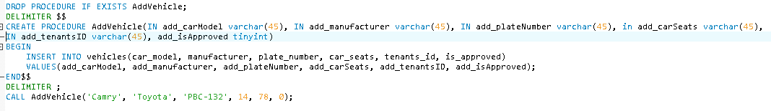

**AddVehicle(IN add_carModel varchar(45), IN add_manufacturer varchar(45), IN add_plateNumber varchar(45), in add_carSeats varchar(45),**

**IN add_tenantsID varchar(45), add_isApproved tinyint)**





**>**sample output<

1. Add New Pet

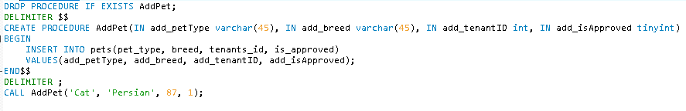

**AddPet(IN add_petType varchar(45), IN add_breed varchar(45), IN add_tenantID int, IN add_isApproved tinyint)**





**>**sample output<

1. Add New Employees

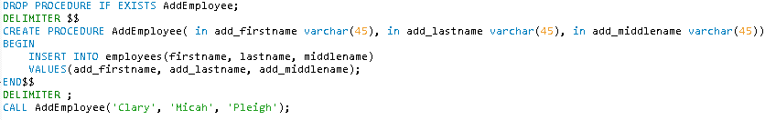

**AddEmployee( in add_firstname varchar(45), in add_lastname varchar(45), in add_middlename varchar(45))**





**>**sample output<

1. Add New Service

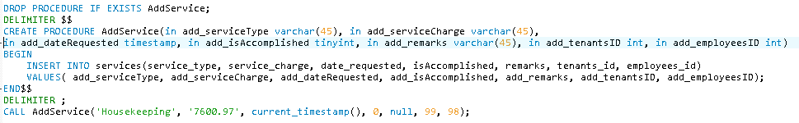

**AddService(in add_serviceType varchar(45), in add_serviceCharge varchar(45),**

**in add_dateRequested timestamp, in add_isAccomplished tinyint, in add_remarks varchar(45), in add_tenantsID int, in add_employeesID int)**





**>**sample output<

1. Update Pets

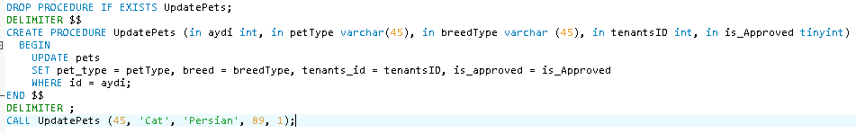

**UpdatePets (in aydi int, in petType varchar(45), in breedType varchar (45), in tenantsID int, in is_Approved tinyint)**





**>**sample output<

1. Update Tenants

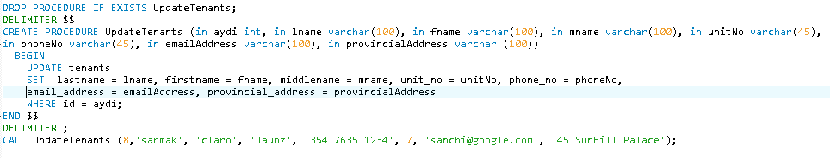

**UpdateTenants (in aydi int, in lname varchar(100), in fname varchar(100), in mname varchar(100), in unitNo varchar(45),**

**in phoneNo varchar(45), in emailAddress varchar(100), in provincialAddress varchar (100))**





**>**sample output<

1. Update Employees

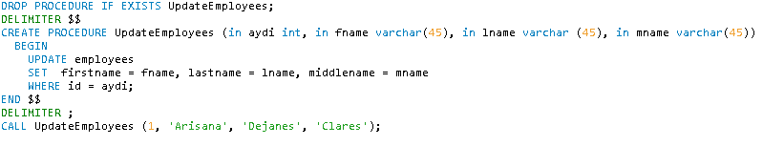

**UpdateEmployees (in aydi int, in fname varchar(45), in lname varchar (45), in mname varchar(45))**





**>**sample output<

1. Update Services

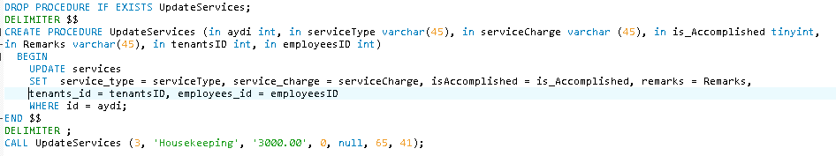

**UpdateServices (in aydi int, in serviceType varchar(45), in serviceCharge varchar (45), in is_Accomplished tinyint,**

**in Remarks varchar(45), in tenantsID int, in employeesID int)**





**>**sample output<

1. Update Vehicles

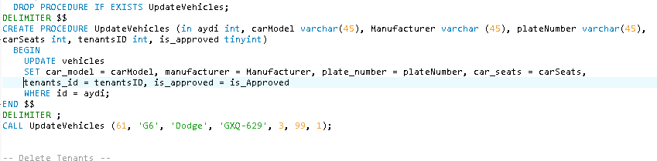

**UpdateVehicles (in aydi int, carModel varchar(45), Manufacturer varchar (45), plateNumber varchar(45),**

**carSeats int, tenantsID int, is_approved tinyint)**



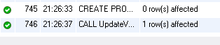

**>**sample output<

1. Delete Tenants

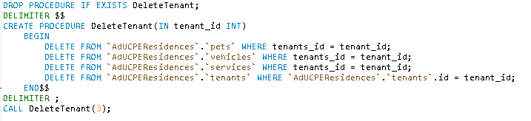

**DeleteTenant(IN tenant_id INT)**





**>**sample output<

1. Delete Employees

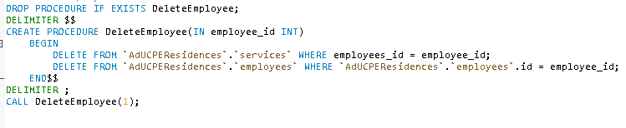

**DeleteEmployee(IN employee_id INT)**





**>**sample output<

1. Delete Vehicles

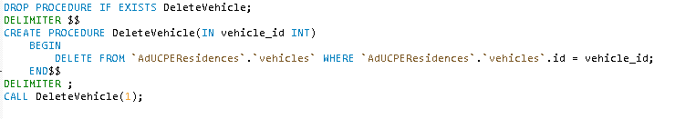

**DeleteVehicle(IN vehicle_id INT)**





**>**sample output<

1. Delete Services

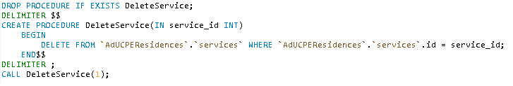

**DeleteService(IN service_id INT)**





**>**sample output<

30. Delete Pets

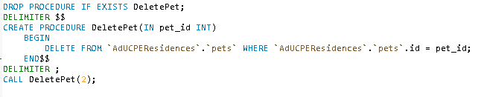

**DeletePet(IN pet_id INT)**





**>**sample output<

31. Read Tenants



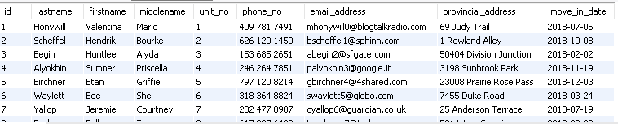

**>**sample output<

32. Read Pets



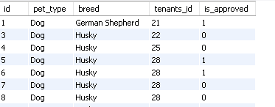

**>**sample output<

33. Read Vehicles



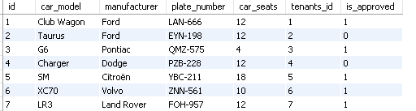

**>**sample output<

34. Read Employees



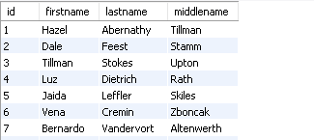

**>**sample output<

35. Read Services



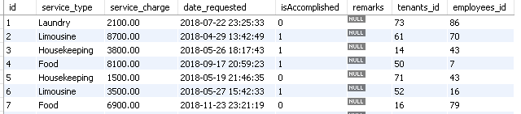

**>**sample output<